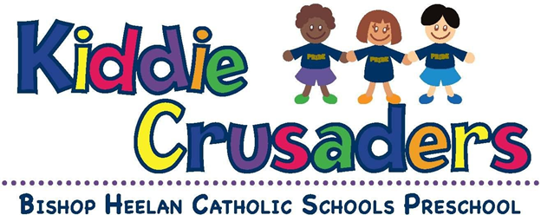
Parent Handbook
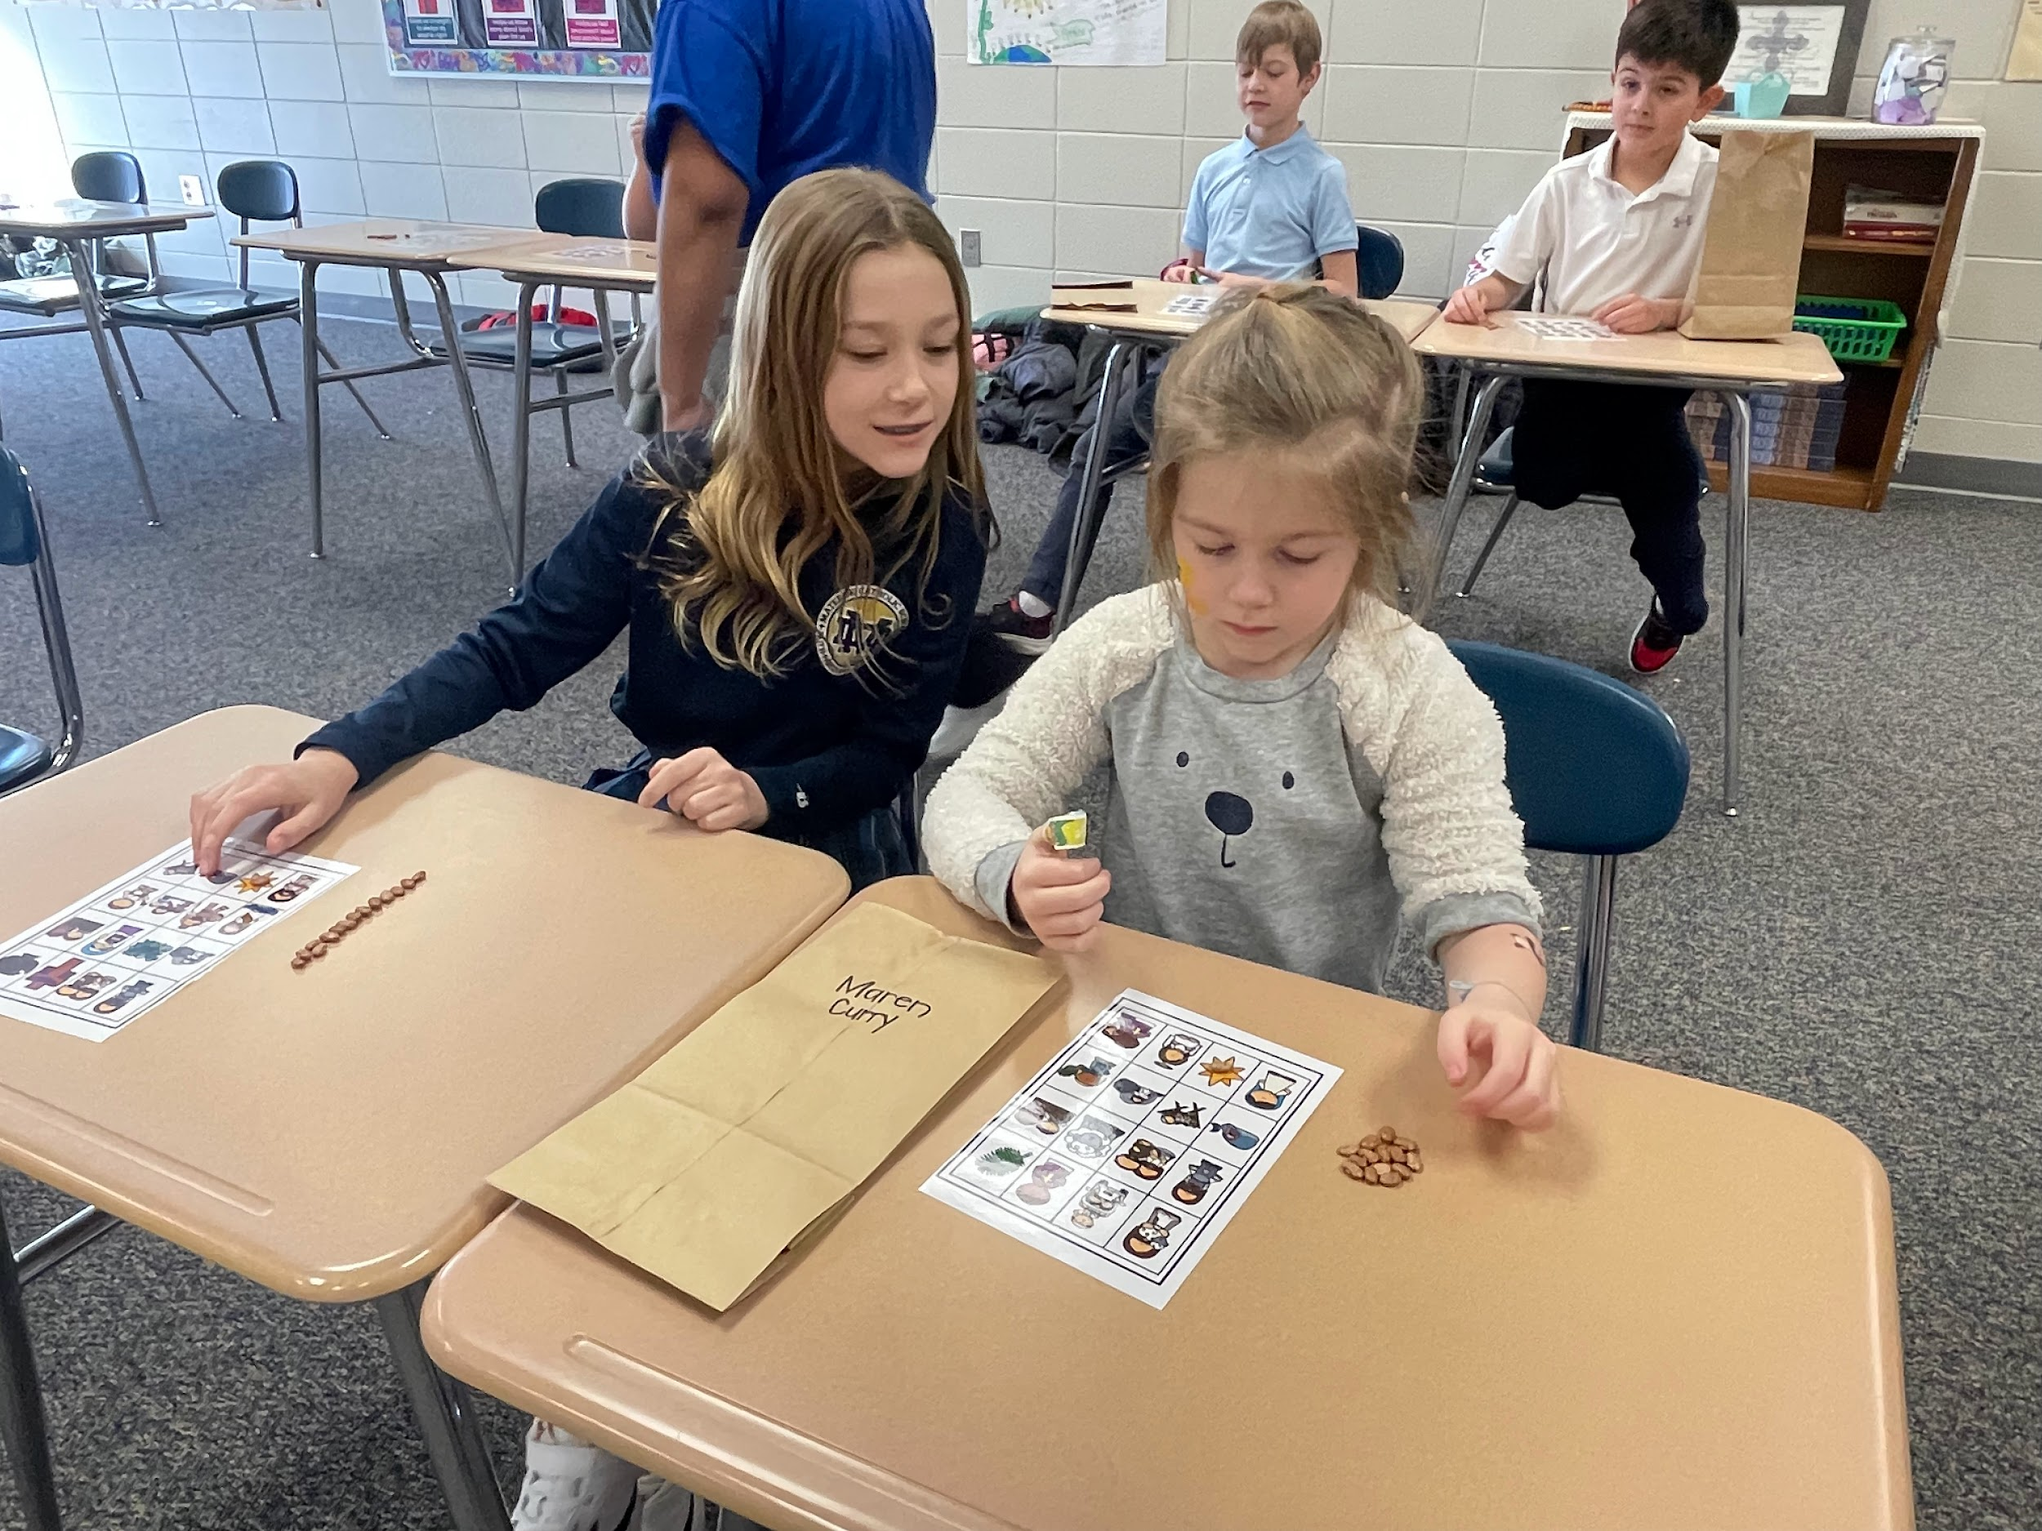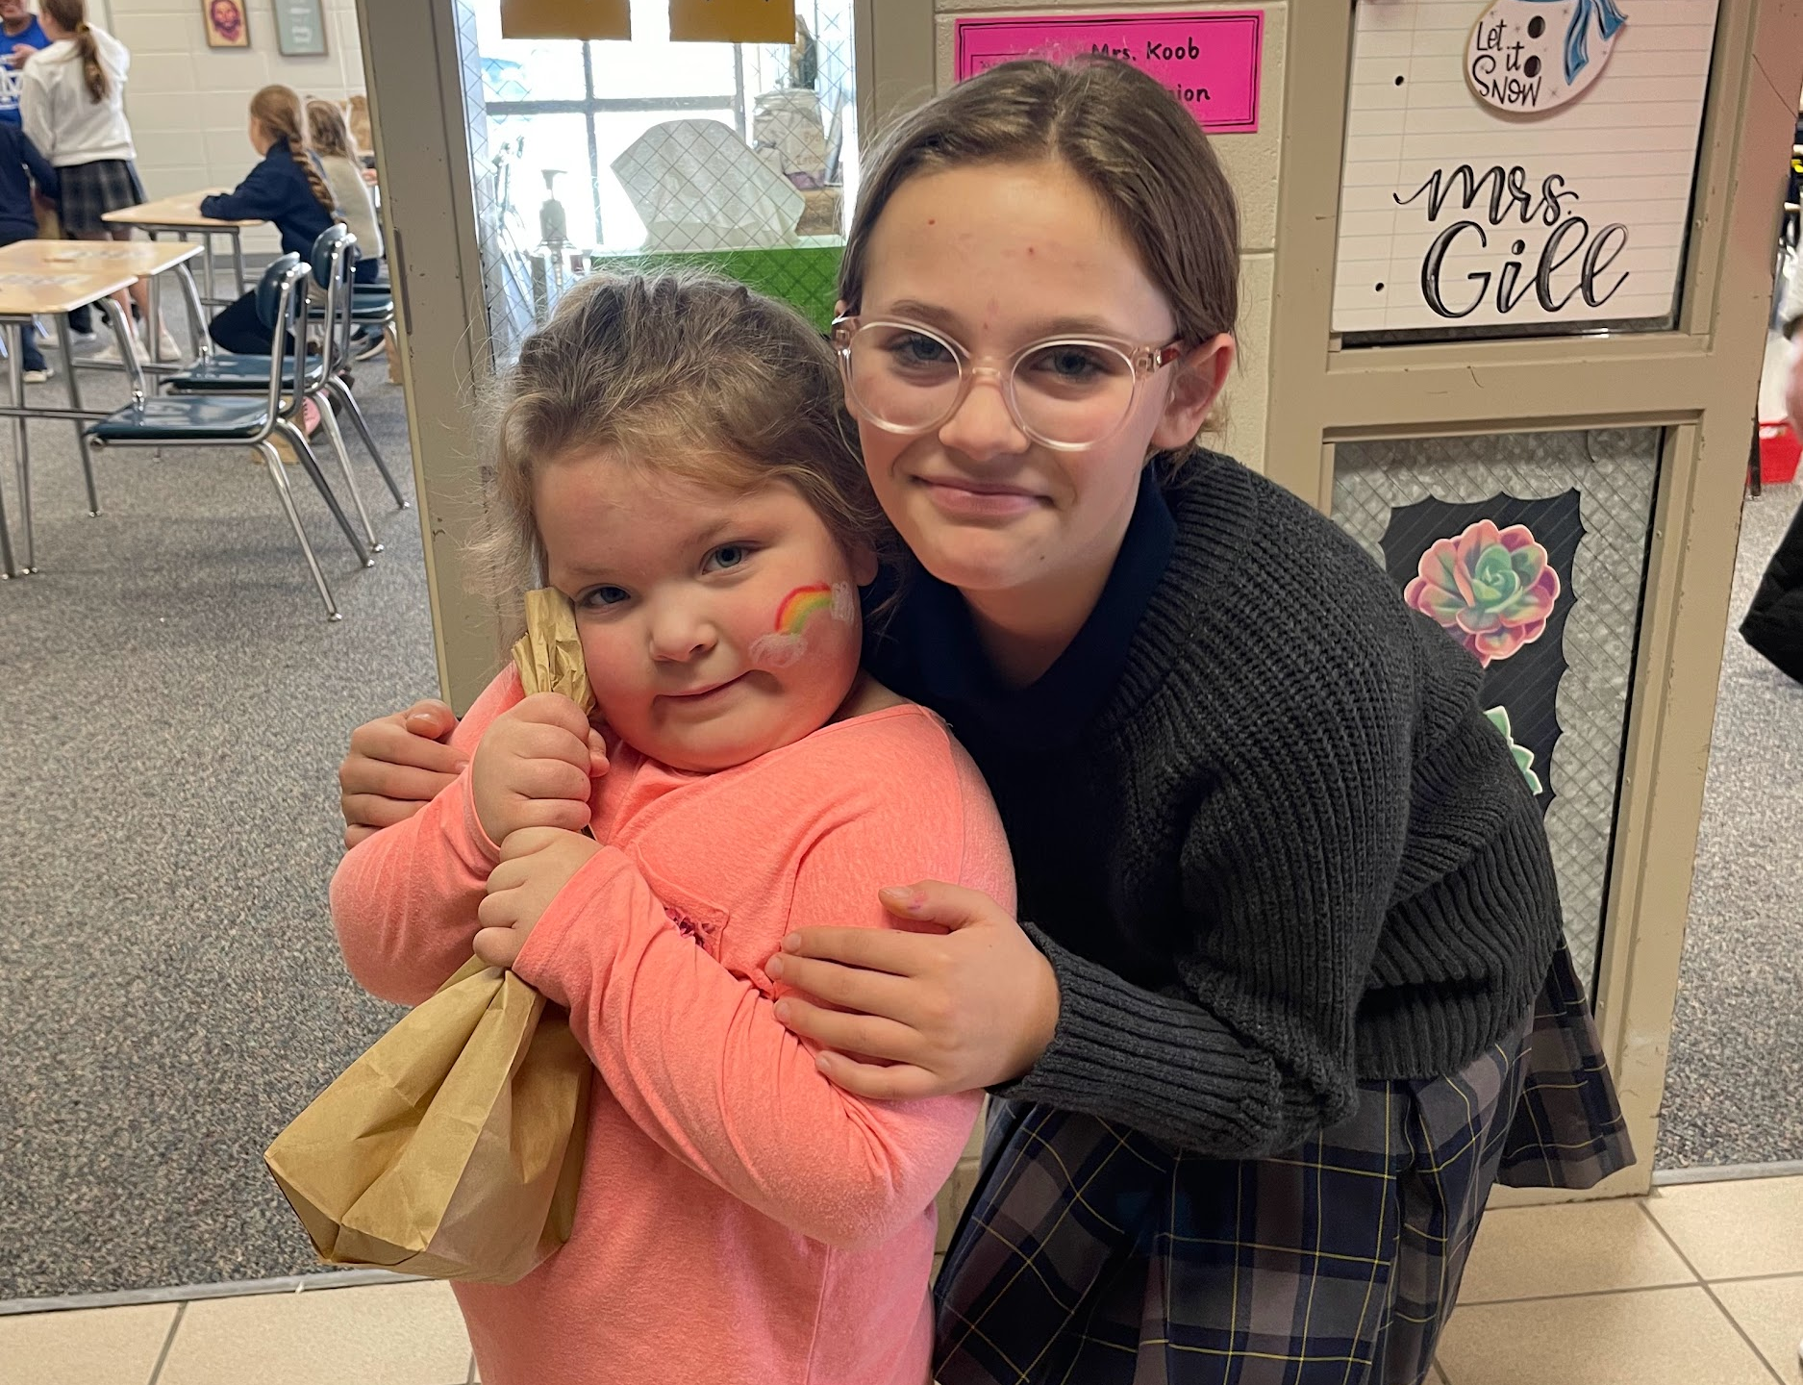
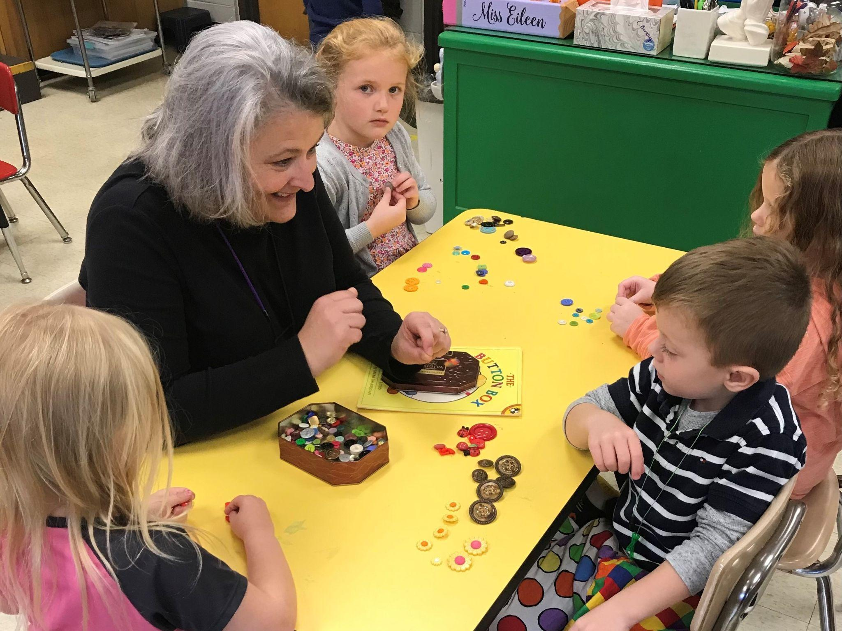

Our Philosophy
Our preschools offer the perfect balance of learning and play in a safe, nurturing and stimulating environment for children. Our caring teachers are dedicated to creating lifelong learners. We develop productive parent-teacher partnerships, keeping families involved and connected to what their children are learning and discovering.
We have an obligation to provide care and education in a safe, healthy and nurturing environment. Furthermore, we are responsible for communicating, collaborating and cooperating with each family to bring home and school together to foster each child’s development.
By specifying standards of excellence for instruction and for the arranged learning environment, the curriculum helps children develop confidence in their ability to learn. They begin to develop self understanding, self-worth and self-discipline. They also begin to gain an understanding and appreciation of the world around them, including individuals different from themselves.
Our goal is to provide a loving, safe environment and an exceptional educational program to help children develop:
A healthy self-concept Trust in peers and adults
Social and emotional awareness Enjoyment of the learning experience
Cognitive, physical and language skills Security
Independence Sense of responsibility to self and others

We also strive to help parents by communicating:
Realistic, age-appropriate expectations for their children
Methods of child guidance and clarifying values
Sensitivity to cultural differences

Nondiscrimination
Our school does not discriminate in employment or the provision of educational services on the basis of race, color, religion, age, gender, national origin, disability, citizenship status, veteran status or any other characteristic protected by federal, state or local law.

General Information
Prior to participating in the program, health records that document the dates of service shall be submitted that show the child is current for routine screening tests and immunizations according to the schedule recommended and published by the American Academy of Pediatrics.
The maximum class size in each session is based on square footage of the current location. Our center maintains a ratio of 1 adult to 10 children at all times and settings including indoor time, outdoor time, and field trips. Additional staff may be provided based on the individual needs of children. Classroom student numbers will not exceed 20 and the number of children allowed is based on usable square footage. All children will be within “line of sight” of adults both indoors and outdoors unless toileting. When toileting, students will be monitored by sound and checked visually when necessary. First Aid Kits are available for use in the classroom and taken outdoors at all times.
The elementary principal will maintain a current list of available substitutes for both the teacher and paraeducator. Should one of the teaching staff need to temporarily leave the room, arrangements will be made to cover the classroom to maintain the staff-child ratio.
Inclusion
The preschool program includes all children, including those with disabilities and unique learning needs. Modifications are made in the environment and staffing patterns in order to include children with special needs. Staff are aware of the identified needs of individual children and are trained to follow through on specific intervention plans. It is our belief that inclusion in our program will enrich the experience for teachers, students, other children and their families. The preschool facilities meet the Americans with Disabilities Act accessibility requirements.
A CHILD’S DAY
Who Works In the Preschool Program
Administrator
The elementary principal is designated as the program administrator supervising the preschool program. The principal meets all qualifications described in the Iowa Quality Preschool Program Standards. The program is also overseen by the preschool administrator of the Sioux City Community School district.
Teacher
A full-time teacher licensed by the Iowa Board of Educational Examiners and holding an Early Childhood endorsement is assigned to the preschool classroom. Teachers participate in joint and collaborative training events with other early childhood educators and community service agencies.
Teacher Assistant
A full time teacher assistant in the classroom carries out activities under the supervision of the teacher. The teacher assistant will have specialized training in early childhood education.

School Nurse
The preschool will have the assistance of the school nurse. The current nurse is available part time, is a certified RN, and is recertified every three years. She maintains student health records by updating them quarterly, and attends to the health needs of the students while they are at school. She is available for parent consultation when necessary. Administrative assistants are trained in medicine distribution.
Support Staff
Northwest Area Education Agency support staff provide resources and assistance to the teacher and classroom upon request to help all children be successful in the preschool setting. Such staff may include: early childhood consultant, speech and language pathologist, social worker, occupational therapist, physical therapist or others.
Daily Activities
A consistent daily schedule is planned to offer a balance of learning activities. Learning is both formal and informal. Play is planned for every day. Listening is balanced with talking, group activities with solitary time, indoors with outdoors, quiet play with noisy play.
Your child will have the opportunity for the following types of activities every day:
• Large and Small Group Activities
• Self-directed Play
• Learning Center Activities: Art Center, Science Center, Writing Center, Fine Motor Center, Reading Center, Block Center, Dramatic Play Center, Computer Center, Music Center
• Story Time
• Individual Activities
• Outdoor Activities
• Rest Time

.
Curriculum
Curriculum is a framework for learning opportunities and experiences. It is a process by which learners obtain knowledge and understanding, while developing life skills. It is continually revised and evaluated to make learning fun and exciting. It is the policy of this district that the curriculum content and instructional materials utilized reflect the cultural and racial diversity present in the United States and the variety of careers, roles, and lifestyles open to women as well as men in our society. One of the objectives of the total curriculum and teaching strategies is to reduce stereotyping and to eliminate bias on the basis of sex, race, ethnic origin, religion, and physical disability. The curriculum should foster respect and appreciation for the cultural diversity found in our country and an awareness of the rights, duties, and responsibilities of each individual as a member of a multicultural nonsexist society.
The preschool program uses Creative Curriculum, research and evidence based comprehensive curriculums designed for three to five year-olds. It addresses all areas of early learning: language and literacy, math, science, physical skills, and social skills. It provides children an opportunity to learn in a variety of ways - through play, problem solving, movement, art, music, drawing and writing, listening, and storytelling. Suggestions for modifications and adaptations are an integral part of the curriculum.
Assessment
The Preschool Initiative classroom uses Teaching Strategies GOLD Assessment for all children. GOLD is an authentic, observational assessment system that is designed to help identify what children know and can do, their strengths, needs and interests. It is also informed by family culture, experiences, children’s abilities and disabilities, and home language.
The primary purposes of the GOLD assessment is to assist teachers in:
● Observing and documenting of children’s development and learning over time,
● Supporting and guiding classroom planning and instruction,
● Identifying children who might need special help or further evaluation,
● Communicating with family members,
● Identifying children’s interests and needs,
● Planning program improvement
Observation notes are taken throughout the day during play and daily routines. Notes are entered into an online system and scored three times per year (Fall, Winter & Spring). The areas of assessment include: social-emotional development, physical development, cognitive development, language development, literacy, mathematics, science & technology, the arts, and social studies. Specific objectives document progress in English language acquisition for children who are learning English. Information from the GOLD assessment is shared with families at conferences and upon request. Parents are also encouraged to participate in the assessment process by documenting what their child/ren can do at home and sharing it with the teacher. Assessment data is analyzed and interpreted weekly, as well as after each assessment period to determine how to best meet the needs of the children and develop goals. This information is then used during lesson planning to best meet the needs of the children.

Registration
Your child must be four years old by September 15thto be eligible for Kiddie Crusaders. Register online at www.bishopheelan.org to hold your child’s spot.
Forms
In the fall the office staff or teachers will collect a copy of your child’s birth certificate, most recent physical (within the last year), and immunization record at the Fall Open House or home visit. Copies of the most recent dental and vision screenings are optional. See the online registration tab for all other necessary forms that will need to be returned in the fall. Files are kept current and confidential and are located in a central secure location.
Dress Code
Students in preschool are not required to wear uniforms. They may wear play clothes that are comfortable and easy for them to manage. Please make sure they are neat, clean and free from holes or frayed edges. We ask that the children wear these shirts on field trips and other special events.
Hot Lunch
Bishop Heelan Catholic Schools maintains an excellent, nourishing hot lunch program. All meals are prepared daily in their kitchen. Lunch and milk count are taken every morning. Lunch is included in the preschool tuition costs.
Snacks
Two snacks will be offered daily. Water will be provided during snack times.
Parent-School Communication .
Kiddie Crusaders provides a school calendar/menu monthly and a newsletter throughout the year. The calendar and newsletter are available on our website (www.bishopheelan.org). Paper copies will be sent home with your child upon request. Information regarding whole school activities will be included. The preschool teachers may provide weekly, monthly and/or daily correspondence with parents.
Kiddie Crusaders establishes relationships with and uses the resources of the community to support the achievement of program goals. Teachers cna share a list with families and assist them in locating, contacting and using community resources that support childrens’ and families’ well-being and development.

Home Visit
Home visits are made prior to the start of school. This is an opportunity for the preschool teacher to get to know you, your child, and your family and for you to begin to create a partnership between home and school in order to best meet your child’s needs. It also allows your child to become familiar and comfortable with his/her teacher and have any questions you may have answered. This is a great time for you to share what makes your family unique, how you prefer to communicate with the teacher, and share your knowledge about your child’s interests, approaches to learning, and developmental needs. You can help the teacher understand what your goals are for your child and whether you have any concerns you’d like addressed. Parents are encouraged to share these preferences, concerns, and questions at any time with either the classroom teacher or administrator.
Parent/Teacher Conferences
Parent/Teacher Conferences are held in October and February to coincide with the K-8 conference schedule. Parents are invited to meet with the teachers to discuss their child’s progress. These conference times will be set up through the preschool teacher.
Board Participation
Parents have an opportunity to join the Preschool Board by talking to the building principal. Board meetings are held every other month or quarterly.

HEALTH AND SAFETY
Kiddie Crusaders Preschool promotes the nutrition and health of all children and protects them from preventable illness and injury. The program has written policies to promote wellness and to safeguard the health and safety of children and adults. All employees are mandatory reporters and follow procedural safeguards.
General Health and Safety Guidelines
All staff must be alert to the health of each child, known allergies, or special medical conditions. Under the supervision of the preschool teacher, all staff must be alert to the whereabouts of all children. Systems are in place for accounting for children at regular intervals, especially during periods of transition. All staff are to follow proper procedures for hand washing, using disinfectant, and following universal precautions to prevent infections. All staff are familiar with evacuation routes and procedures. All teaching staff complete “Occupational Exposure to Bloodborne Pathogens'' annually. At least one staff member who has a certificate of satisfactory completion of pediatric first aid training, including managing a blocked airway and providing rescue breathing for infants and children, is always present with each group of children. One staff person who has successfully completed training in CPR is present in the program at all times.
To protect against cold, heat, and sun injury, and insect-borne disease, the program ensures that:
- Children wear clothing that is dry and layered for warmth in cold weather.
- Children have the opportunity to play in the shade.

For children who are unable to use the toilet constantly, staff will check diapers or pull ups regularly and change the child in the designated changing area following the posted changing procedures.
All staff that interact with preschool children are mandatory reporters and required to follow policies and procedures accordingly.
The program has policies and procedures to follow in the event of reported abuse.

Hygiene

Children will be encouraged to learn good hygiene habits. Adults and children, guided by teachers, will wash hands with soap and water upon entering the classroom, before preparing, serving, or eating snack, after using the bathroom, after handling animals, before and after sand or water play, after handling bodily fluids (blowing or wiping nose, coughing on a hand, or touching mucus, blood, or vomit), and after playing outdoors. Adults also wash hands before and after feeding a child, administering medication, after assisting a child with toileting, and after handling garbage or cleaning.

Adults and children follow the proper handwashing procedures which include using liquid soap and running water and rubbing vigorously all areas of the hands and wrists for at least 20 seconds, drying with a paper towel, and using a paper towel to turn off the water. When soap and water are not available, hand sanitizer with 60-90% alcohol may be used.

For children who are unable to use the toilet consistently and wear diapers, staff check diapers every two hours and change the diaper in the designated area when wet or soiled by following the diaper changing procedures that are posted. The diaper is disposed of in a hands-free garbage can that is inaccessible to children.

In order to prevent the spread of infectious disease during water play, staff will remind children not to drink the water, exclude children with sores on their hands, change the water for each group of children, and empty the water table at the end of play time

Nutrition Guidelines
Food for meals is prepared, served, and stored in accordance with the U.S. Department of Agriculture Child and Adult Care Food Program guidelines.
All children with special health care needs will have an action plan prepared by a health care professional with full instructions to properly care for the child if an emergency shall arise. This includes food allergies, allergies to bee stings, or chronic illness that require assistive technology.
Illness Policy and Exclusion of Sick Children
For the health and safety of all the children, it is mandatory that sick children not be brought to school. If your child has any of the following symptoms during the night, he or she will not be admitted the following morning for the safety of the other children.
• fever greater than 100 degrees F
• vomiting
• diarrhea
• pink eyes with drainage
• cough with congestion and excessive nasal discharge
• cold sores or lesions
The schools’ established policy for an ill child’s return:
• Fever free for 24 hours
• Chicken pox: one week after onset (or when lesions are crusted)
• Strep: 24 hours after initial medication without the aid of medication
• Vomiting/Diarrhea: 24 hours after last episode
• Conjunctivitis: 24 hours after initial medication or when without drainage
Upon arrival at school, each child is observed by teaching staff for signs of illness or injury that could affect the child’s ability to participate comfortably in the daily activities. Children will be excluded when a child is not able to participate comfortably; if the illness requires more care than staff are able to provide without compromising the needs of the other children in the group; or if keeping the child at school poses an increased risk to the child or to other children or adults with whom the child will come in contact.
When a child develops signs of an illness during their day at preschool, parents, legal guardians, or other person authorized by the parent will be notified immediately to pick up the child. For this reason, please be sure that we have current, accurate phone numbers for you, your authorized emergency contact person and your child’s pediatrician. In the meantime, we will provide the child a place to rest until the parent, legal guardian or designated person arrives under the supervision of someone familiar with the child. If the child is suspected of having a contagious disease, then, until she or he can be picked up, the child is located where new individuals will not be exposed.
Staff and teachers provide information to families verbally and in writing about unusual level or type of communicable disease to which their child was exposed, signs and symptoms of the disease, mode of transmission, period of communicability , and control measures that are being implemented at the program and that the families should implement at home.
Medication Policies and Procedures
Policy: The school will administer medication to children with written approval of the parent and an order from a health provider for a specific child. Because administration of medication in the school is a safety hazard, medication administration will be limited to situations where an agreement to give medicine outside preschool hours cannot be made. Whenever possible, the first dose of medication should be given at home to see if the child has any type of reaction. All medications are kept in a locked cabinet or container.
Procedure: The office staff coordinates and/or administers medication during school hours only if the parent or legal guardian has provided written consent and the medication is available in an original labeled prescription or manufacturer’s container that is child-resistant. Any other person who would administer medication has specific training and a written performance evaluation, updated annually by a health professional on the practice of the six right practices of medication administration:
(1) verifying that the right child receives the (2) right medication (3) in the right dose (4) at the right time (5) by the right method with documentation of each time the medication is given. (6)The person giving the medication signs documentation of items (1) through (5) above. Teaching staff who are required to administer special medical procedures have demonstrated to a health professional that they are competent in the procedures and are guided in writing about how to perform the procedure by the prescribing health care provider.
Medications are labeled with the child's first and last names, the date that either the prescription was filled or the recommendation was obtained from the child’s licensed health care provider, the name of the medication or the period of use of the medication, the manufacturer’s instructions or the original prescription label that details the name and strength of the medication, and instructions on how to administer and store it.

Cleaning and Sanitization
The facility will be maintained in a clean and sanitary condition. When a spill occurs, the area will be made inaccessible to children and the area will be cleaned immediately. Toys that have been placed in a child’s mouth or that are otherwise contaminated by body secretion or excretion will be removed immediately and disinfected after they are cleaned with soap and water. This also applies to other surfaces in the classroom. Toys and surfaces will be disinfected using a non-toxic solution of hard surface cleaner and water made fresh daily. To disinfect, the surfaces will be sprayed until glossy. The cleaning solution will be left on for at least two minutes before it is wiped off with a clean paper towel, or it may be allowed to air dry. Machine washable cloth toys that have been placed in a child’s mouth or that are otherwise contaminated by body secretion or excretion must be laundered before another child’s use. Toys that cannot be cleaned and sanitized will not be used.
Staff will be trained in cleaning techniques, proper use of protective barriers such as gloves, proper handling and disposal of contaminated materials, and information required by the US Occupational Safety and Health Administration about the use of any chemical agents.
Routine cleaning will be supervised by the preschool teacher and will follow the Cleaning and Sanitation Frequency in the QPPS manual. A checklist will be completed as indicated in the table. Facility cleaning requiring potentially hazardous chemicals will be scheduled when children are not present to minimize exposure of the children. All cleaning products will be used as directed by the manufacturer’s label. Non Toxic substances will be used whenever possible. Staff are trained yearly prior to the start of the school year.

Hand Washing Practices
Frequent hand washing is key to preventing the spread of infectious diseases. Teachers teach children how to wash their hands effectively. Posters of children using proper hand washing procedures are placed by each sink. The program follows these practices regarding hand washing:
• Staff members and those children who are developmentally able to learn personal hygiene are taught hand-washing procedures and are periodically monitored.
• Hand washing is required by all staff, volunteers, and children when hand washing reduces the risk of transmission of infectious diseases to themselves and to others.
• Staff assist children with hand washing as needed to successfully complete the task. Children and adults wash their hands:
• upon arrival for the day;
• after diapering or using the toilet (use of wet wipes is acceptable for infants);
• after handling body fluids (e.g., blowing or wiping a nose, coughing on a hand, or any touching of mucus, blood or vomit);
• before meals and snacks, preparing or serving food, or handling any raw food that requires cooking (e.g., meat, eggs, poultry);
• after playing in water that is shared by two or more people;
• after handling pets and other animals or any materials such as sand, dirt, or surfaces that might be contaminated by contact with animals Adults also wash their hands:
• before and after feeding a child;
• before and after administering medication;
• after assisting a child with toileting
• after handling garbage or cleaning. Proper hand-washing procedures are followed by adults and children and include

First Aid Kit
It is inaccessible to children, but readily available for adult use. It is fully equipped according to guidance from Healthy Child Care Iowa. Following each use of the First Aid kit, the contents will be inspected and missing or used items replaced immediately. The First Aid kit will be inspected monthly. The first aid kit is taken to the outdoor play areas as well as on field trips and outings away from the site.
Safety Preparedness
A fire extinguisher is installed in the preschool classroom with a tag indicating its annual service date. The fire alarm system is serviced annually. Smoke detectors, fire alarms, and carbon monoxide detectors are tested monthly. A written log of testing dates and battery changes is maintained and available upon request. Fire drills are conducted twice a year and recorded on a log. Intruder drills and evacuation drills will be conducted throughout the year.
The program has written and posted disaster preparedness and evacuation policies and procedures.
In order to ensure your child’s safety, we encourage you to develop safety rules for arrival and dismissal from school. Make sure that your child and the teachers know who will be picking up at the end of the day. Please stress the importance of using sidewalks, how to cross the street at a stoplight, and safety around vehicles.
In order to provide the safest environment possible, all Kiddie Crusader sites use a secure entry system. The main door at each site is the only door to enter and exit. A buzzer and video camera system allows school personnel to see who is requesting entry into our facility. All individuals are asked to identify themselves and the purpose of their visit. This process is for the safety of all present.

Visiting School
You are welcome to visit your child’s classroom whenever it is in session. Please notify your child’s teacher if you plan a visit to the school.
Schedule
Kiddie Crusaders: Preschool classes are all day, every day sessions with preschool initiative designated times.
Sacred Heart’s school day runs from 8:30 a.m. to 2:30 p.m. on Monday and 8:30 a.m.-3:30 p.m. Tuesday-Friday. Students may be dropped off at school as early as 7:30 a.m. where they will be supervised in the classroom. There is no additional charge for before school care. After school care will be available on site until 5:30 p.m. for an additional fee. Students must be picked up within 15 minutes after dismissal to ensure their safety. Staff members are often called out of the building for meetings, and supervision is not always available. Sacred Heart Preschool initiative hours are from 8:30-12:30 with wrap around care covered by tuition.
Mater Dei’s school day runs from 8:15 a.m.-2:15 p.m. on Monday and 8:15 a.m.-3:15 p.m. on Tuesday-Friday. Students may be dropped off at school as early as 7:30 a. m. where they will be supervised by staff in the gym. There is no additional charge for before school care. After school care is not available onsite. Several daycare vans provide transportation to and from school and offer after school care. Students must be picked up within 15 minutes after dismissal to ensure their safety. Staff members are often called out of the building for meetings and supervision is not always available. PI hours at Mater Dei Kiddie Crusaders are Mon-Thurs 8:30-3:15. Fridays are used to focus on our faith with all school mass in the morning and religion class in the afternoon.
The Holy Cross Preschool day runs from 8:15-2:05 on Mondays and 8:15-3:05 on Tuesday- Fridays. We dismiss preschool 10 minutes prior to the end of the Saint Michael Center school day in order to allow time for preschoolers to be picked up without being overwhelmed with the large group of older children. Students may be dropped off as early as 7:30 in the morning and will be supervised by a staff member in the gym. There is no charge for before school care. We offer after school care onsite through Beyond the Bell. It is for preschool - 5th grade. Please visit their website for more information. Holy Cross Preschool Initiative hours are 9:00-2:00 Monday through Friday with wrap around care covered by tuition.
The CYO preschool classrooms, Dual Language Academy and Sacred Heart run from 8:00-2:00 on Mondays and 8:00-3:00 Tuesday-Friday. Students may be dropped off at school as early as 7:30 a.m. where they will be supervised in the classroom. There is no additional charge for before school care. After school care will be available on site until 5:30 p.m. for an additional fee. Students must be picked up within 15 minutes after dismissal to ensure their safety. Staff members are often called out of the building for meetings, and supervision is not always available. Sacred Heart preschool at the CYO and the Dual Language Preschool initiative hours are from 8:30-1:30 daily with wrap around care covered by tuition.

Money
If money is sent with your child for any reason, please put it in an envelope marked with your child’s name, classroom teacher’s name and the purpose for which the money is being sent.

Parent Groups
Sacred Heart Kiddie Crusaders: PSG stands for Parent School Group. This group of parents, teachers, and administrators plan various activities throughout the school year. The group’s mission is to encourage involvement in school activities and support teachers and staff. Additional PSG information will be available in the fall.
Mater Dei Kiddie Crusaders: PTO stands for Parent Teacher Organization. This group of parents and school personnel work together to plan various activities and fund-rasing events. Monthly meetings are held and all parents are invited to attend and participate.
Holy Cross Kiddie Crusaders: PTO stands for Parent Teacher Organization. This group is made up of parents, teachers and administrators working together to support teachers, students and staff. PTO holds several events each year and a monthly meeting to help foster a faith filled community environment for our school. All families enrolled in Holy Cross School are members, are encouraged to be involved, and are welcome at all events.
Dual Language Academy Kiddie Crusaders PTO stands for Parent Teacher Organization, This group of parents, teachers, and administrators plan various activities throughout the school year. The group’s mission is to encourage involvement in school activities and support teachers and staff. Additional PTO information will be available in the fall.
Kiddie Crusader Contact Information
If you have any questions please contact your Kiddie Crusader site:
Sacred Heart Kiddie Crusaders- 233-1624. Mrs. Connealy, principal, can be reached at kate.connealy@bishopheelan.org.
Mater Dei Kiddie Crusaders-276-6216. Ms. Fischer, principal can be reached at mary.fischer@bishopheelan.org.
Holy Cross Kiddie Crusaders -239-1090. Mrs. Roder, principal can be reached at wendy.roder@bishopheelan.org.
Dual Language Academy Kiddie Crusaders- 233-1624. Mrs. Connealy, principal can be reached at kate.connealy@bishopheelan.org

